Terminal Email Client

🖥️ What Is a Terminal Email Client?
# Source: AI Source: Provided by: [Data Path: Persons Table -> ID Column: 1, Name_En Column: Motasem Essam] -> From: [Chatgpt (GPT‑5 Mini)] on [1/21/2026]
A Terminal Email Client is an email program that runs inside a text-based terminal or command-line interface (CLI), usually on Linux or Unix-based systems.
It's designed for users who prefer or require keyboard-only control, scripting, and low-resource environments — such as servers or developers.

💡 Why Use a Terminal Email Client?
# Source: AI Source: Provided by: [Data Path: Persons Table -> ID Column: 1, Name_En Column: Motasem Essam] -> From: [Chatgpt (GPT‑5 Mini)] on [1/21/2026]
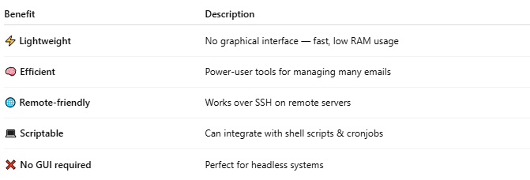

Benefit | Description
⚡ Lightweight | No graphical interface — fast, low RAM usage
🧠 Efficient | Power-user tools for managing many emails
🌐 Remote-friendly | Works over SSH on remote servers
💻 Scriptable | Can integrate with shell scripts & cronjobs
❌ No GUI required | Perfect for headless systems

🧰 Popular Terminal Email Clients
# Source: AI Source: Provided by: [Data Path: Persons Table -> ID Column: 1, Name_En Column: Motasem Essam] -> From: [Chatgpt (GPT‑5 Mini)] on [1/21/2026]
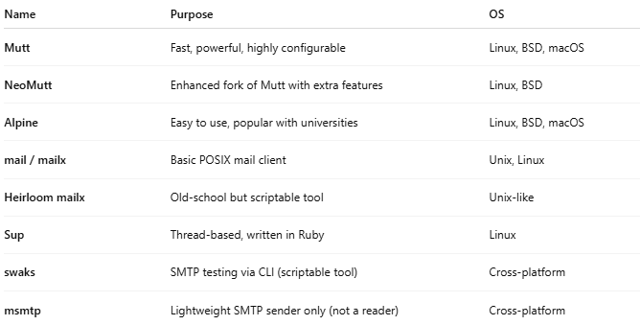

Name | Purpose | OS
Mutt | Fast, powerful, highly configurable | Linux, BSD, macOS
NeoMutt | Enhanced fork of Mutt with extra features | Linux, BSD
Alpine | Easy to use, popular with universities | Linux, BSD, macOS
mail / mailx | Basic POSIX mail client | Unix, Linux
Heirloom mailx | Old-school but scriptable tool | Unix-like
Sup | Thread-based, written in Ruby | Linux
swaks | SMTP testing via CLI (scriptable tool) | Cross-platform
msmtp | Lightweight SMTP sender only (not a reader) | Cross-platform

📤 How It Works
# Source: AI Source: Provided by: [Data Path: Persons Table -> ID Column: 1, Name_En Column: Motasem Essam] -> From: [Chatgpt (GPT‑5 Mini)] on [1/21/2026]
A terminal client typically connects to:
- IMAP → To view and manage inbox on the server
- SMTP → To send email
- Maildir/mbox → Local email storage formats

Example: How You Use Mutt
# Source: AI Source: Provided by: [Data Path: Persons Table -> ID Column: 1, Name_En Column: Motasem Essam] -> From: [Chatgpt (GPT‑5 Mini)] on [1/21/2026]
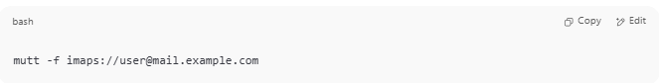
mutt -f imaps://user@mail.example.com

- Navigate with keyboard
- Press m to compose a message
- Press y to send
- Press q to quit

🆚 Terminal vs GUI Clients
# Source: AI Source: Provided by: [Data Path: Persons Table -> ID Column: 1, Name_En Column: Motasem Essam] -> From: [Chatgpt (GPT‑5 Mini)] on [1/21/2026]
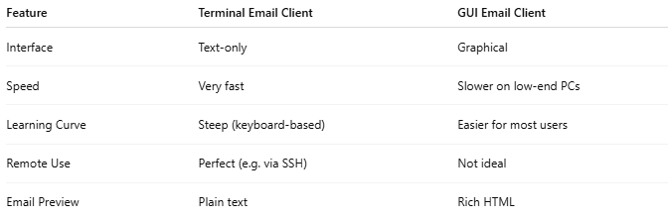
Feature | Terminal Email Client | GUI Email Client
Interface | Text-only | Graphical
Speed | Very fast | Slower on low-end PCs
Learning Curve | Steep (keyboard-based) | Easier for most users
Remote Use | Perfect (e.g. via SSH) | Not ideal
Email Preview | Plain text | Rich HTML

🧠 Use Cases
# Source: AI Source: Provided by: [Data Path: Persons Table -> ID Column: 1, Name_En Column: Motasem Essam] -> From: [Chatgpt (GPT‑5 Mini)] on [1/21/2026]
- 💻 System administrators managing mail servers
- 👨‍💻 Developers automating mail tasks in Linux
- 📦 Docker containers with no GUI
- 🧪 Testing email sending in CLI-based dev environments

✅ Summary
# Source: AI Source: Provided by: [Data Path: Persons Table -> ID Column: 1, Name_En Column: Motasem Essam] -> From: [Chatgpt (GPT‑5 Mini)] on [1/21/2026]
A Terminal Email Client is a powerful, text-based tool that runs in a terminal.
It's best for Linux users, server admins, and developers who prefer speed, control, and scripting over graphical interfaces.

Would you like help installing or using Mutt or Alpine on your Linux or WSL terminal?

